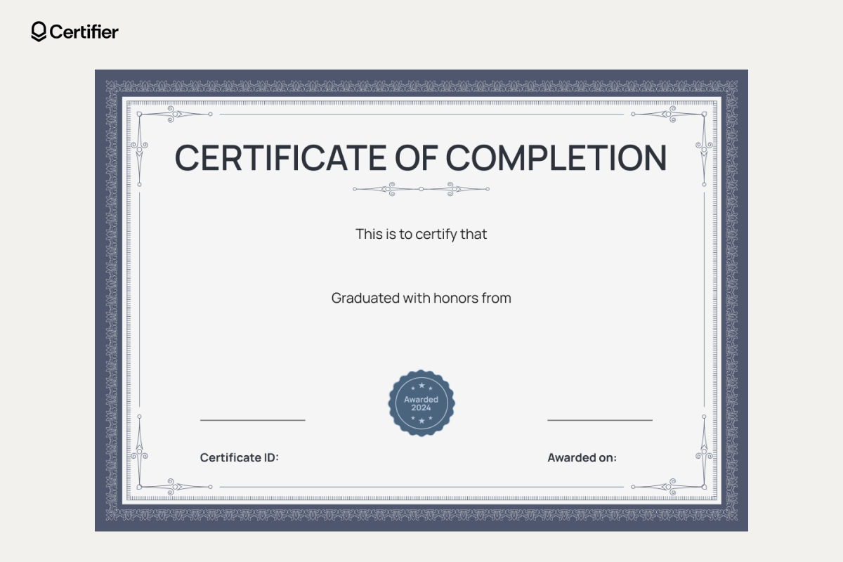
2026-09-01 00:00:00
23CSE001
CSE
Ananya Reddy

